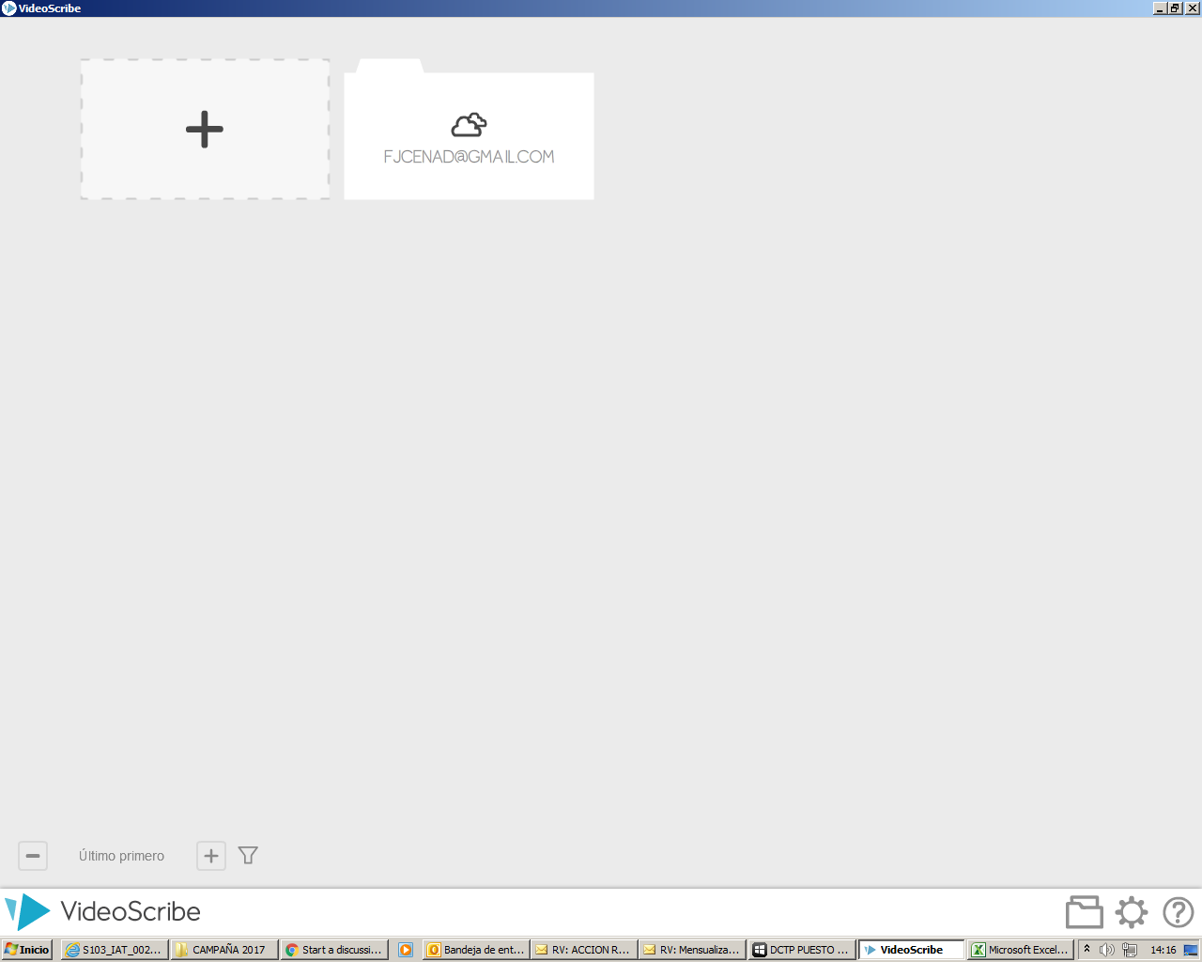

My Project was saved here when I was doing it by free trial, but now it´s empty!